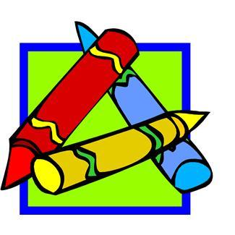

Christian Collegiate Academy
Fourth Grade Supply List
2024-2025

- ___ 1 pack yellow #2 pencils
- ___ 1 in. black binder
- ___ 2 large pink eraser
- ___ 1 pencil box (plastic)
- ___ 3- 24-ct. boxes of Crayola crayons (NOT the washable kind)
- ___ 1 pkg. of Crayola washable markers
- ___ 1 pkg. of Crayola colored pencils
- ___ 4 glue sticks
- ___ scissors
- ___ 2 large boxes of Kleenex
- ___ 6 dry-erase markers (any colors but at least 2 black)
- ___ King James Version Bible (NOT New King James)
- ___ 1 ream of plain white copy paper
- ___ 1-10oz. bottle of germ-x
- ___ 1 watercolor paint set
- ___ 8 pack of dividers
- ___ 2 plastic folders (1 green, 1 yellow)
- ___ 1 bottle of red tempera paint
- ___ 1 Mixed Media Sketch pad
- ___ 1 container of Crayola Air Dry Clay
- ___ 2 thin black sharpies
- ___ 2 packs of lined paper
- ___ 1 pack 4x 6 index cards (girls only)
- ___ 1 pack of sticky notes (boys only)
- ___ 2 rolls paper towels
- ___ 1 pkg googly eyes

