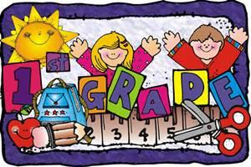
Christian Collegiate Academy
First Grade Supply List
2024-2025
1 Book Bag (no wheels, please)
1 Coloring Book
4 Pack of Purple Glue Sticks
1 Sturdy Pencil Box
2 Pack of Ticonderoga Pencils
3 Pack of Paper Mate White Erasers
4 Pack Tissues
4 Pack Sanitizing Wipes
2 Plastic Folders (1 Red, 1 Blue)
1 KJV Bible
2 Pack of crayons (24)
2 Pack of Thin Markers
1 Pack of Fat Markers
1 Pair of Blunt Tip Scissors
2 Reams of Paper
2 Big Bottles of Hand Sanitizer
Ziploc bags- boy(quart) girls(gallon)
2 pkg. cap erasers
1 watercolor paint pallet
1 bottle white paint
1 pack colored pencils

