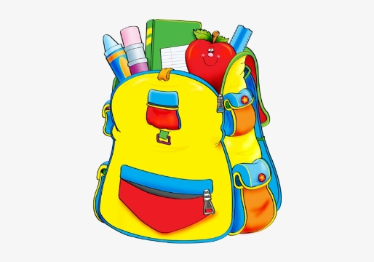
K4 Supply List
- Regular size backpack(no wheels, please)
- small snack bag
- 1 pencil box (8x5)
- 2 Jumbo yellow pencils
- 4 large Elmer’s glue sticks
- 1 rounded scissors
- 3 (24 count) Crayola crayons
- 1 Playdoh (4 count or more)
- 2 boxes of Crayola Washable Markers (Classic colors)
- 2 pocket folders
- 2 coloring books
- 1 ream white copy paper
- 2 large boxes of tissues
- 1 Child’s rain coat or easy open umbrella(this will stay at school)
- 1 seasonal change of clothes ( in Ziploc bag with child’s name)
- nap mat (red/blue, no sleeping bags or comforters)
- travel size pillow and blanket (no sleeping bags or comforters please)
- 2 containers Clorox wipes
- 1 package of baby wipes
- 1 package ziploc bags (boy-quart; girls-gallon)
- 2 pack of construction paper
- 1 pkg. of washable Crayola paint
- 1 box of Band-aids
- 1 watercolor paint pallet

